DAY8 SESSION ASSIGNMENTS

1.When to use (Rapid Application Development) RAD model
When not to use (Rapid Application Development) RAD model

RAD CAN BE USED:

- A Rapid Application development model is used when a product is to be delivered in a short span of time.
- RAD model is used where the customers need a prototype of the actual product and the customers want to accomodate changes in the project when and where required.
- RAD should be used only if there is high availability of resources be it be human or tools requirements.RAD requires high experts .
- RAD SDLC model should be chosen only if domain experts are
- available with relevant business knowledge.
- It should be used only if the budget permits use of automated
- code generating tools
- RAD should be used when there is a need to create a system that can be modularized in 2-3 months of time.
- Developers who are time challenged could use this application development

RAD SHOULD NOT BE USED:

- RAD cannot be used if the system cannot be modularised.
- Inapplicable to cheaper projects as cost of modelling and automated code generation is very high.
- RAD cannot be used if the customer is not ready to get involved and makes a statement that he just needs the end product and not any prototype.
- RAD cannot be used if there is unavailability of high resources like experts.
- Dependency on technically strong team members for identifying business requirements

3.Describe the Entity Relationships for the following diagram
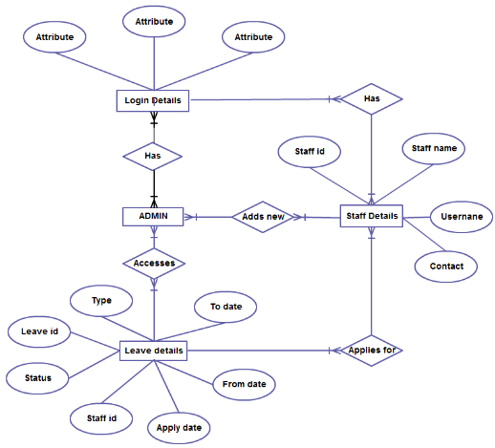

- Here we have mainly 4 entities namely the admin,login details,staff details and leave details.
- Staff details is the entity having the attributes staff id,staff name,contact and username.
- Leave details is the entity having the attributes leave id,type,status,from date,apply date,staff id and to date.Here the staff id acts as the foreign key.
- Login details has 3 attributes.
- The Admin has a realationship has with the entity login details.
- Here there are two main users:the admin and the staff.
- The first step is to login.ie,both the user and admin needs to login to this system
- Admin needs to login because then only he can provide with necessary updations during user processings and all.
- The admin has to approve the staff so that he can login.
- The Admin has the power to add new staff.
- Multiple staffs can be logged in,but for one staff he/she can have only one login id.
- Various functions will be there that the staff can have access to but here it is the leave application that is done.
- The staff can apply for leave and this is depicted through the applies for realationship.

2.Define an ER diagram of a software Organization with all the relationship model that was discussed in class.

use
m.type
m.name
n
methodology
sex
address
pname
name
age
salary
m
worksfor
dateofjoining
m n
Employee
Project
e.id
pid
n
contacts

Client
request
1
clientname
Client_num

- Here the entity employee has attributes name,sex,age,salary,address,date of joining,e.id.Here the contacts act as the multivalued attribute.
- Many employees can work many projects.ie.m to n.
- Here a project can have only 1 client but 1 client can have many projects.
- The entity client have client_num and clientname as the attributes.
- The entity project has the attributes project name and project id as pnum,pid respectively.
- The entity project has a relationship use with the entity methodology.
- Here various methodologies can be used in many projects.i.e m to n.

